**First Area Credit Union**

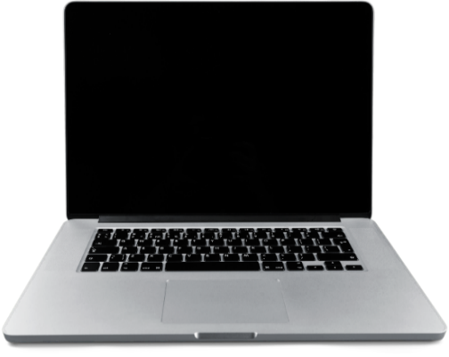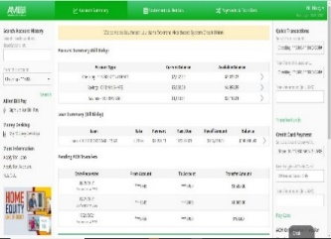

1. Go to **First Area’s website (firstareacu.com) and click on Home Banking button then click “Register your Account”.**
2. Review and Accept the Terms and Conditions.
3. Validate your account by typing in your Credit Union Account Number, Social Security Number, Street Address, and Date of Birth.
4. Setup your account by entering a Username, your Email Address, and Password.
5. Select any account options you wish to use.
6. Login to your account using the information entered during your account setup. A multi-factor 6-digit number will be sent to the email address that was entered during the setup of your account. This number will need to be entered correctly prior to accessing your account.
7. Once you have entered the Multi Factor Authentication code, you can then register the device you are logging in on. By registering the device, you will not be required to enter another Multi factor Authentication number next time you log in on that device.



**WELCOME TO OUR NEW ONLINE BANKING SYSTEM**

**First Area Credit Union’s new Online Banking Registration will be available starting**

**November 12th, 2024.**

**How to Register**

**193 Campbell Lane**

**Saginaw, MI 48609**

**Tel (989) 781-1430**